

American International University- Bangladesh

CSC 3222: Web Technologies

Mid-Term Project Report

Fall 20-21

Project Title:**Educational Institute Managment Website**

Section: G

|  |  |
| --- | --- |
| Student Name | Student Id |
| AHMED, RASEL | 17-33188-1 |
| DAM, BIPROJIT KUMAR | 17-33189-1 |
| TIASH, JUNAED KIRON | 17-33384-1 |
| RAHMAN, MD.AREFUR | 17-33945-1 |

Introduction:

*Our project name is Educational Institute Managment Managment Website. It is a porject where we tried to build a system where those who are associatively working and trying to learn over there,may have a way to inter-connect with each other. And also our another mission is to have a list of associated members and provide a identical access inside our system .*

Background Study

* AIUB website
* NSU website
* IUB website

Requirement Analysis:

1. User Category:

There are 4-types of Users here. They are:

* Admin
* Teacher
* Student
* Employee

1. Feature List:

In this project the “Admin” has the following features:

* Login.
* Logout.
* Profile page.
* .Student List view.
* .Teacher List view.
* .Emplyoee List view.
* Student Add.
* Teacher Add.
* Employee Add.
* View Result.
* view notice.
* Upload Notice.
* Update Salary Date.
* View Salary Date.

In this project the “Teacher” has the following features:

* Login.
* Logout.
* Add Student.
* view Student.
* Result Publish.
* .View note .
* view notice.
* .upload note.
* .upload notice.

In this project the “Student” has the following features:

* Login
* Logout
* Functionality Menu
* See Notice
* .See Result
* .upload Assignment
* .See Note

Design:

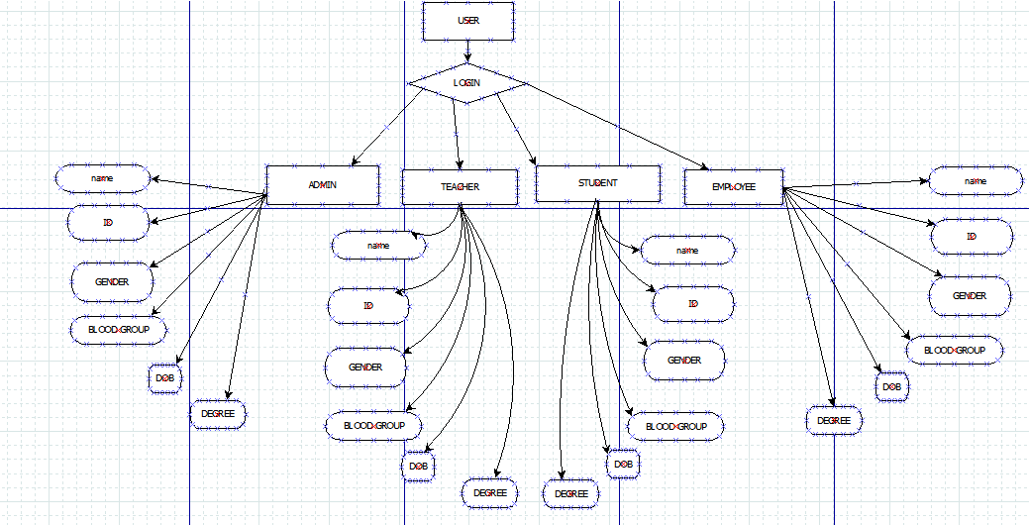

Tools Used:

To develop this project, we have used the following:

• Subline Text Editor

• .XAAMP

System Images against the Specification:

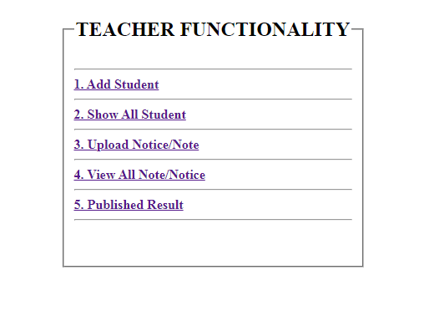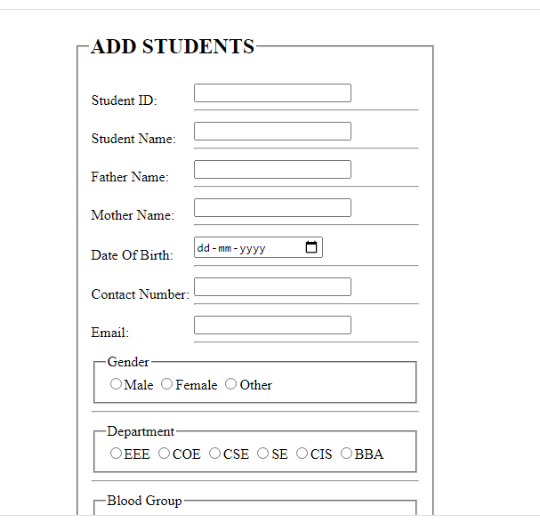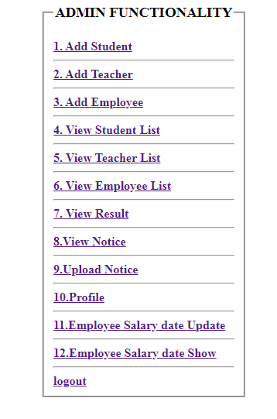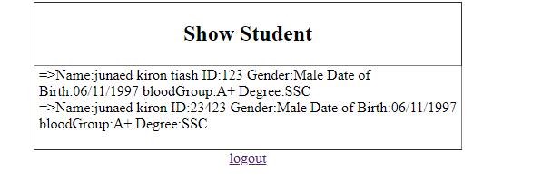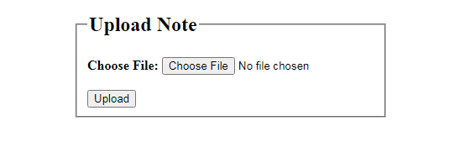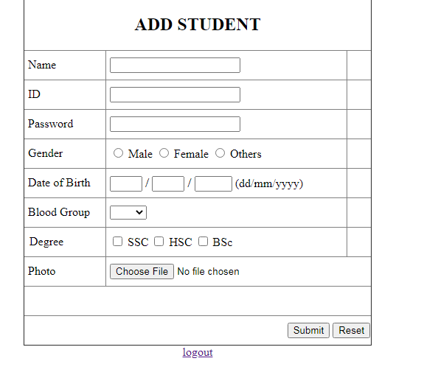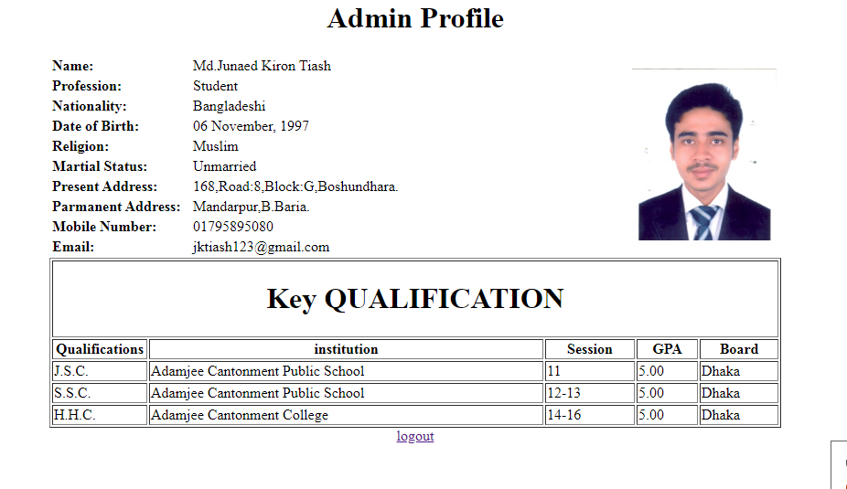

Impact of this Project:

Through this project , if we can reach to our goal point , the communicational medium for our users will defenitly see a new positive and beneficial asspect of communication in this modern era. The managmental senerio will obviously find a easy way to be done. And the institute will get a private platform of their own which will provide a online official srevice for their members. And in this era of web community,it will also be an online promotion which is able to reach to the whole world.

Limitations and Possible Future Improvements:

* Not able to connect Database.
* Design was not in syllabus.
* Online learning activity.
* Security.
* Lack of resourcing.

|  |  |  |  |  |  |
| --- | --- | --- | --- | --- | --- |
| CO1.1 and CO2.1 Evaluation: Project Report Evaluation | | | | | |
| Project Proposal  (5) | Background  Study  (5) | Requirement Analysis  (5) | Entity  Diagram  (5) | System Images  against the  Specification (5) | Total (25) |
|  |  |  |  |  |  |
|  | | | | | |